The Fish Stick Volume One

Local High School Installs Windmill

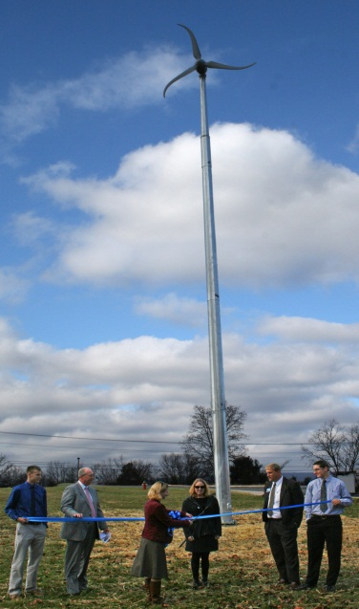
(Shenandoah County Public Schools Website)

Heather Landes
In November 2012, Central High became one of only ten schools in Virginia to install a windmill. This impressive
achievement was thanks to the revolutionary program: Wind for Schools. This program, facilitated by James Madison University, focuses on one goal: introducing the youth of America to the vast possibilities of clean energy. Since the mission of this program focuses on education, Central received funding from the Moore Educational Trust along with the Dominion Foundation.
Many community members became concerned when the idea to install a windmill was first introduced to the school board several years ago. However, after much research and persuasion, the supporters eventually outnumbered the dissenters. Thus, Central became the county’s center for environmental education.
Those that initially opposed the installation of the windmill did so because they thought that the benefits would not outweigh the initial cost. Although they were right in stating that there would not be a payback, the idea that the windmill will not be beneficial to the
students of Central is completely untrue. The windmill will only generate enough energy to power one classroom, but the educational value will be priceless.
Christopher Kaznosky and Meredith Bauserman were among the many educators working towards a greener campus for Central. These extraordinary teachers worked extremely hard to plan every, single detail of the windmill project. Without these two diligent teachers, it is hard to imagine Central ever getting a windmill.
Thanks to the hard work of many educators, the generous funding from various institutions, and the coordinating efforts of James Madison University, Shenandoah County now has a way to teach young people about the endless possibilities of wind energy.

Table of Contents
1 | Wind
2 | Solar
3-4 | River
5 | Environment
6 | Agriculture/Environment
7-8 | Entertainment
9-10 | Statistics/Entertainment
11 | Classified
12 | Editor’s Page

Five Facts about Global Warming

Heather Landes

30: The number of years before Canada’s climate becomes identical to America’s.
6 percent: The amount that insurance has gone up for many Americans, due to the increase in natural disasters.
61 percent: The amount of increase in ragweed pollen due to increased CO₂ emissions.
2 to 5: The increase in the likelihood someone in a developing country will get cholera, due to rising water temperatures.
10 to 11: The number of super typhoons over the yearly average.

Learn the facts at http://www.edf.org/

Strasburg Family Makes Economic and Environmental Savings from Solar Power
Madison Doehler
If you are one who keeps your outdoor lights on every night for the sole purpose of better visibility, you probably aren't aware of the savings you haven't taken advantage of. More importantly, you haven't realized how much the environment is impacted by using too much electricity! There is a better, less expensive, and and more Eco-friendly way to have better visibility in the dark: active solar energy.
David Doehler, 53, has been lighting the walkway to his house with active solar lights since 2008, and has saved an average of $81.72 per year just on
electric light bulbs! Aside from Doehler's incredible investment, he is also using electricity created from sunlight instead of electricity from costly fossil fuels!
Doehler claims that he first got this idea from his brother, who uses passive and active solar for outdoor appliances. “Having electricity that has been generated by solar cells has saved me money, but I must say that there is really no such thing as 'green' energy,” states Doehler. “What are the benefits if the photo- transforming cells are manufactured in a factory where the pollutants are emitted?
Having the lights is nice, but we need to find a way to make green energy 'green'.” Not only has active solar energy caused Doehler to save on his monthly electricity bill, but has encouraged him to expand his use for “green” concepts, such as gathering rain water instead of using tap water. Doehler's belief poses one question: are we really doing ourselves a favor by investing in these environmentally-friendly concepts and devices?

Weather
Thursday  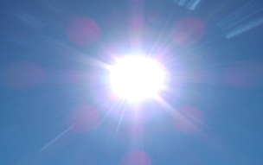 | Friday | Saturday
High: 75 ° | High: 80° | High: 68°
Low: 56° | Low: 61° | Low: 59°
Description: Mostly sunny today. | Description: Mostly sunny today. | Description: Mostly cloudy today with an 80% chance of thunderstorms in the early afternoon.
Farmers, today would be a great day to fertilize the lawn with environmentally friendly fertilizer. | Today would be a great day to prime your solar panels. | Today would be a great day to not work in the garden. This is an erosion hazard!

The Shenandoah River
Pamela Panzino
The Shenandoah River appears to be beautiful and plentiful from the outside. However, there are horrific incidences that have had a profound effect on the river. There are two primary sources of contamination that can be accredited with the pollution of the Shenandoah River.
The first and most direct source is from Du Pont Co. Starting in 1929 and going until about 1950, Du Pont is almost entirely responsible for the mercury toxicity in the river. Since, during this time, there were no laws to control what was being poured into the river, it wasn’t until the 70’s that the serious contamination of the South Fork of the river was discovered. After a long settlement, Du Pont Co. in Waynesboro, VA was told they needed to establish a trust fund to aid in the cleanup of the river. They also established a 100-year monitoring of the mercury levels. This was started in 1989, however, even after the most recent study, there does not seem to be any signs of the mercury wearing down anytime in the near future. In fact, mercury levels are as high as they were at the
beginning of the monitoring. The problem is that once something has been introduced to the river, it is not as simple as taking it out. Mercury in particular is extremely difficult. Mercury has its way of not only remaining in the bodies of organisms while they are living, but also when they are consumed. The continuous cycles of exposure and consumption have managed to work mercury straight through the food chain of the Shenandoah River.
The Shenandoah River will be feeling the effects of Du Pont for many years still to come. The second source of contamination is an abstract contaminant that took a long time to trace. It is something that almost everyone contributes to. It is the waste water management practices. After waste water is taken into the treatment plant, it goes through various cycles that break down the waste and separate it from the water (i.e. nematodes are consumers of much of solid waste). The only thing that doesn’t actually get taken out of the water is excess hormones. Hormones are introduced to the treatment plant just like everything else there was: humans. Between estrogen pills, oral birth control, testosterone, steroids, and other medical supplements, it makes it hard to control the amount being poured back into the river. These hormone levels have caused extremely unusual behaviors in the Shenandoah River fish. There has been an overwhelming number of fish take on behavior of the opposite sex as well as fish born hermaphrodite. These confused fish have been struggling for so long that the numbers of offspring have slowly begun to decrease in most recent years.
All of the struggles of the river have been considered and there are multiple groups established to try to protect the condition of the river. One of the strongest advocates of the river is the Friends of the Shenandoah River (FOSR). They take the initiative to inform locals and build relationships between people and the river. There are laws in place to protect people from consuming too much mercury and becoming victim to the rivers issues. Although the river has its issues, it is still a very clean and healthy river. One should not take for granite all the positive changes and sights the river has to offer. Hopefully, a solution to these problems can be devised to restore this beautiful river to its former glory.

Below are a few pictures of the beautiful Shenandoah River.
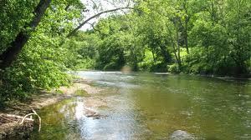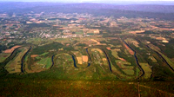

Stream Wars
Heather Landes

This week we will be comparing McKay Spring, and Spout Run.
McKay Spring is known to have an all-time low temperature of approximately twelve degrees Celsius, and an all-time high of approximately fourteen. Inversely, Spout Run has an all-time low temperature of one degree Celsius, and an all-time high of around twenty. Therefore, McKay Spring has less fluctuation when it comes to temperature. One point McKay Spring!
Furthermore, the amount of Ammonia in Spout Run spiked in July of 1997, while the level has remained close to zero in Crooked Run. Also, Spout Run experienced a massive jump in turbidity in 2010, most likely due to flooding, while McKay Spring slow trickle has not faltered. A second point for McKay Spring!
Lastly, the nitrogen levels of both McKay Spring and Spout Run have remained dangerously high. This is a huge problem, because these two streams have the ability to affect organism living downstream. No points.
And the winner is: McKay Spring! Stay tuned, because next week we’re going to be comparing the James River and the Potomac! Thanks to http://www.fosr.org/water/ for all of their information!

Local Environmental Groups
Guadalupe Reynoso
There are a number of local groups with a mission of protecting our local environment. Accomplishments of these groups are numerous and have included keeping the Shenandoah Valley clean and free of any litter. Friends of the North Fork of the Shenandoah River, the Resource Conservation and Development Program, and the Northern Shenandoah Valley Audubon Society are just a few of the groups worth mentioning. The great thing about all of these groups is that they are quickly growing in

popularity and support all around our community.
The Friends of the North Fork is dedicated to enhancing the purity, beauty and natural flow of the North Fork of the Shenandoah. People in our community can get involved with and help Friends of the North Fork achieve its mission by participating in river cleanups, advocating for positive treatment of the river, educating the public, and raising funds to improve river water quality. The Resource Conservation and Development Program, another group, is involved with protecting the long term health of the river and its natural resources. The RC&D is able to work to achieve its mission through providing volunteer

leadership, technical resources, and financial assistance.
The Northern Shenandoah Valley Audubon Society is open to anyone with an interest in our environment and conservation. Its goal is to conserve and restore natural ecosystems. These groups, as well as others, are always open to new members who are also interested in protecting the environment. Anyone can do their part through donating their time or money to these groups with a great mission. These groups all have pages online with contact information for anyone that may be interested in learning more about the environment and what is being done locally to protect it.
Are You Doing Your Part?

Madison Doehler

MOUNT JACKSON: Students and teachers at Massanutten Regional Governor’s School participated in an interview on May 10, 2013. The purpose of the interview was to identify the demographics of energy and resource conservation. “Do you recycle your recyclable products?" This simple question gets many surprising responses. An average of 64.2% of the responders products are recycled, which means that 35.8% of all of the other products are taken to the landfill where the other trash goes! All of that can be recycled and not be a burden on the environment. The responders have been recycling for an average of 11.5 years, amazingly enough, Mr. R. Newcomer claims to have established the first recycling program in Warren County (1970)! Aside from electricity, 40% of the responders stated that they use solar-powered devices on a regular basis; perhaps the most interesting devices were the PB light cells for outdoor lighting and a solar-powered calculator. Based on these statistics, it is probably not surprising that an average of 90% of the light bulbs used by the responders is either LED or fluorescent! The number of these light bulbs being used influences the amount of electricity that is needed. According to the responses and averages of these MRGS students and teachers, one can definitely say that they are doing their part in energy and resource conservation!

(www.you-can-go-green.com)

Turn That Water Off!
Heather Landes

After asking thirteen students in the J2 class whether or not they turn the water off when they brush their teeth, the surprising, yet pleasing, conclusion emerged that only two out of thirteen

people do not turn the water off when they brush their teeth.
This means that only 15% of the J2 class does not conserve water. Below is a graph to illustrate this:

This data is very pleasing, because it proves that many J2s are working hard to save the environment. According to www.you-can-go-
green.com, when the facet is not turned off while someone is brushing their teeth, it uses an average of 1.875 gallons. If only people were to be more like the J2s, perhaps we could finally have a solution to water conservation.
Look for our next issue to see these results compared with a random sampling of J1s! Who will be the most environmentally aware? Join us next week to find out.

Local Farming

Guadalupe Reynoso
In recent years, many people all over the country have become more interested in buying organic foods. Picking up on this interest, many more farmers have begun using fewer chemicals, as well as improving their sales through marketing organic farming as another way of getting more people to buy their foods over someone else’s. This change is also helping the environment. Fewer chemicals and pesticides are being used, which is helping maintain healthy soil and water quality for many areas around the country. As more people pick up on this trend, we may be helping our environment in more ways than we have yet to discover.
A number of local farms are also adopting organic farming. Many of their products can be found at local food markets, such as the one held weekly throughout the warmer months at the Shenandoah County fairgrounds in Woodstock, VA.
(Continued on page 6).

Buying fruits and vegetables at these local markets not only helps local businesses, it also helps support green farming for a more environmentally stable future.
Everyone is encouraged to go to their local food market sometime soon and test the products of their local organic farmers!

Perhaps the most featured organic product in North America is the tomato. Organic farming has become rather popular in rural areas.

Social Ecology
Aubtin Heydari

The current system of overconsumption has created unprecedented crisis’s that pose a substantial risk to our future survival. Only a halt to growth and an effort to preserve what we have left can reverse the impacts of our environmentally malicious behavior. Is the answer then more reform and legislation? Or do we instead need a comprehensive change on our approach to both the environment and society? In the wake of the seeming failure of both passing the aforementioned legislature and their inability to be effective, some leftists and eco-anarchists think the latter question is the one we need to be asking.
Social ecology is a philosophy advanced by the late green author and activist Murray Bookchin. A critique of current social, political, and environmental trends, social ecology argues that social hierarchies are the root cause of human dominance over the environment and ecological destruction. These hierarchies and their effect on the human relationship to nature are the root cause of war, poverty, and environmental destruction. He argues that small reforms or new fix-it technologies will fail, and that only radical change can solve environmental destruction. The destruction of our world and the very integrity of life itself are at risk as current reformist approaches towards environment protection continue to fail.
Social ecology’s alternative that Bookchin proposes is “libertarian municipalism,” which posits a transition to small, local, and ethical communities governed by direct democracy. This reconstructive approach to society has a transformative outlook on social and environmental issues that tries to resynchronize humans with the natural world. Social ecologists argue that the issues brought about by the hierarchies of society cannot be challenged alone by changing individual consumption practices or ethical consumerism. By rethinking our ethics and society through the lens of radically democratic ideals, we can create a more mutualistic world that accounts equally for individuals and preserves our beautiful environment.

Eco-Punks
Aubtin Heydari
The Punk Rock genre has long been tied to (radical) leftist politics. The Eco-Punk movement, however, is a relatively new emerging subculture of angry and environmentally conscious musicians and activists. It seems as if there are major contradictions between the Green ideology, which traditionally has been characterized by peace loving hippies, and the fiery spirit of the Punk movement, born out of anger, angst, and rebellion both against the establishment but the hippie aesthetic of 70’s music. Despite being born from different camps, Punk music can help and empower the eco-activist.
Punk music was one of the first genres to heavily focus on social and political issues in their lyrics. While from an outside glance Punk seems to be angry teenagers glamourizing excess and violence, the fundamental tenants of Punk and its origin are far from that and in fact often criticize those values. The genre was born out of discontented lower class young adults of Britain, who felt they were being abused by both society and the government. Political Punk provides a very easy gateway into Eco-Punk, which criticizes the same actors traditional Punk does, except in a different context.

Often times the line distinguishing a political protest and an Eco-Punk concert is indistinguishable. The crowds that come to both are socially and ecologically conscious individuals from all walks of life who want to express their opinion through the vibrant and expressive sounds of Punk. The topics covered in the music range from corporate and government environmental injustices, destruction and abuse of indigenous lands, pollution and deforestation, the growing technological panacea, the abuse of animals, and the general consumerist culture that is permeating all aspects of our lives.
Here are some classic songs for those interested in learning more of the rich style and sound of the Eco-Punk music and their message:
“This is the A.L.F.” by Conflict
“Meat Means Murder” by Conflict
“Kyoto Now!” by Bad Religion
“Nailing Descartes to the Wall (alternatively (Liquid) Meat is Still Murder)” by Propaganhdi
“Nuclear Generators” by Suicide Machines
“Gaia Bleeds (Make Way for Man)” by Set Your Goals

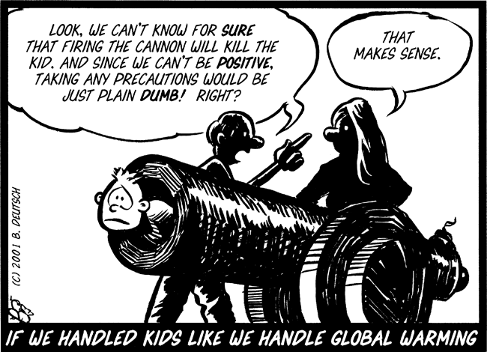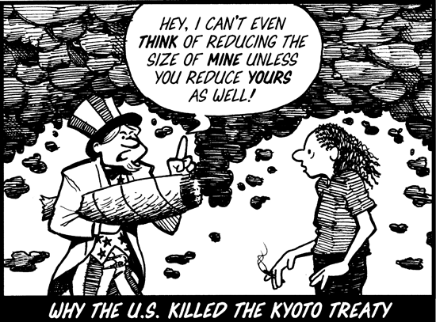

Environmental Film
Movie goers and environmental activists in our area are in luck! Our nation’s capital is home to the Environmental Film Festival, an annual showcase of films informing the public of our environment and exposing ecological injustices. Film styles vary from documentaries, narratives, animations, shorts and even children’s films. For a week and a half every March, varying venues sprawled across the DC area screen over 190
films from over 50 countries. This is an incredibly unique experience that is a must-see for local environmentalists or general movie buffs.
This past year was the 21st Environmental Film Festival. It featured an astonishing 110 US and World premieres. The amount of energy being put into the event shows just how prestigious it is. Among those that debuted this year:

Film Name | Genre | About
Lunacracy! | Documentary | Examines people who are obsessed with the moon
Hot Water | Documentary | Exposes the toxic effects of uranium mining in the American West
Amazon Gold | Documentary | Exposes the destruction of the rainforest in the pursuit of illegally mined gold
Beny, Back to the Wild | Documentary | Tells the story of a bonobo monkey’s return to the wild after being held in captivity
For a Better World! | Series of animated short films | Aimed at children, these films intend to promote environmental awareness
Jane’s Journey | Documentary | Tells the captivating story of the world-famous animal activist, Jane Goodall

The Strasburg Green Team
Pamela Panzino
The Strasburg Green Team is a club at Strasburg High School that emphasizes ways to help the environment. It includes the addition of a compost, a recycling program, and a mission to reach the whole school. Last year, they built and implemented a school wide compost. The idea of the compost was more ingenious than it was ever intended to be. It involved several parts of the school, joining on board to make the project a success.
First was the agriculture department. The agriculture team at Strasburg decided that they could use the compost to their benefit, so long as they were willing to pitch in. This supply of workers were overly willing to use the compost so that their department could use the newly revived soil whenever there is

a need for it. The benefits of the compost are definitely in their favor and will be especially when the compost begins to yield vitamin enriched soil. The next department that the compost has reached is the cafeteria. In order to involve the cafeteria in the compost, there are new bins placed to collect food wastes that can be used in the compost. This incooperates each member of the student body doing their part to create success in the project. It makes the system less wasteful and more productive. Especially so because most students will find at least one or two things on their tray that they aren’t particularly interested in but are included in the meal. Overall, the Green Team is seeing an overwhelming amount of support for their addition to Strasburg High School. Of course, the Green Team is also involved with the recycling programs at Strasburg. (Continued on page 9).
Green Team (Continued)
The recycling programs involve both plastic and paper recycling, as well as selective sites for aluminum recycling. In every classroom, there is both a large bin for paper recycling and a short black bin for plastic recycling. Surprisingly, about 95% of these materials end up being recycled thanks to the system. Everyday, during the last class of the day, there is a worker (on an alternating days work schedule) who goes to each class and picks up the bins and places them in the master bin to be taken to the recycling center. It isn’t uncommon for a student or teacher to remark, “Hey! Use the recycling bin,” to any who try to do otherwise. Recycling has also proven to be a huge success to Strasburg High School.

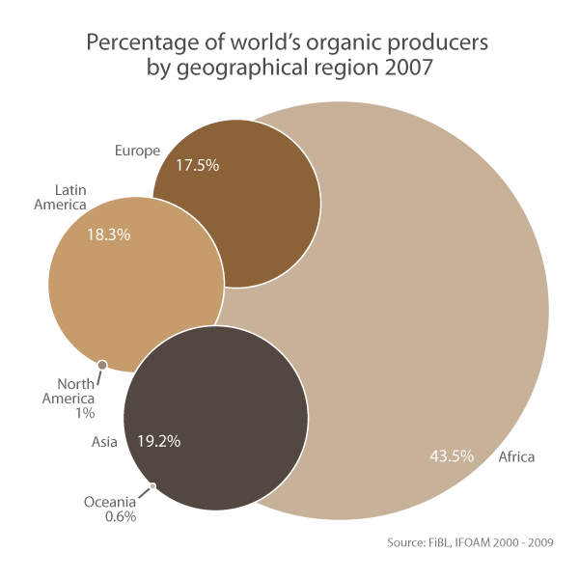
According to Research Institute of Organic Agriculture, above is the 2007 spread of organic agriculture around the world.

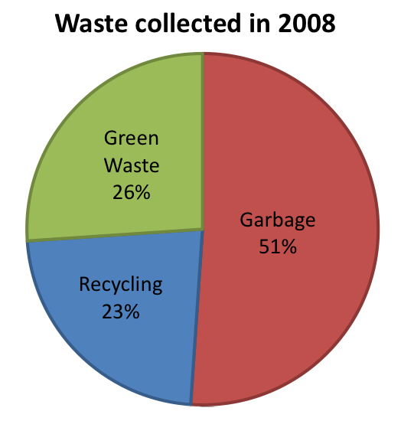
According to the state of California, this was the waste collected in 2008.

Book Reviews
Pam Panzino
The Last Child in the Woods is an informative book about the sad truth of the future of children. Currently, there is a growing decline in the amount of time children spend with nature. According to the book, children are literally being “scared straight out of the woods”. Because of this, more and more children are simply deprived of the spiritual and psychological necessity of spending time outdoors. The cold reality is that the result of spending more time in front of a computer screen and less time playing outside has caused depression in youth. In fact, the now twenty year olds seem to be the last generation with fond memories of spending time outside. Overall, the book is well-written, highly informative, and obviously credible. The Last Child in the Woods is worth the time.
Environmental Do’s and Don’ts
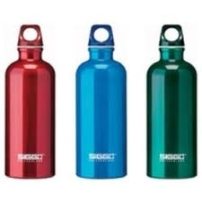

Green Sports
The Harrisonburg High School athletic department is going green. By introducing new regulations and policies, the school’s sports teams are doing their part to help preserve nature and cut back on their carbon footprint. This is all a part of a new trend growing amongst high school students and administrations; where at one point only certain clubs would contribute to the schools environmental efforts, members of the student body and faculty are going green in all ways possible. “The Harrisonburg Athletic Department tries to be as up to the times as possible,” said athletic director Darrel Wilson, “So we should modernize our department so it is part of the green movement.” He further hopes other schools will catch on and follow their model.
There are many ways in which the athletic teams are cutting back and going green. For one, they are changing distributors. Instead of buying jerseys and equipment from big corporations that use materials that aren’t ecologically friendly, they are switching to companies that are ecologically friendly and recycle materials where possible. Even the concession stands are doing their part by composting and using green plates and napkins. The students are now being provided with their own water bottles and urged to not use single use plastic bottles. The groundskeepers are reviewing their maintenance methods and cutting back on harmful fertilizers and pesticides where possible. Additionally, Wilson is coming up with new ways to get the athletes involved in environmental projects. Hopefully other schools will follow in Harrisonburg’s lead and help build a greener future.

CLASSIFIED
JOBS  Landscaper  A landscaper is one who is responsible for trimming and monitoring vegetation in domestic areas.  Prerequisites: Knowledge on different plat varieties and knowledge on how to operate basic outdoor machinery.  Salary: approx. $15/ hour  Contact Number: (540)-555-7327  Florist  A florist is one who arranges flowers for any kind of occasion, such as social events or even for decorating a room.  Prerequisites: Knowledge on different varieties of flowers, knowledge on how to operate basic tools for cutting, bending, etc.  Salary: $15/hour  Contact Number: (540)-555-2355  Water Conversationalist  A water conversationalist is one who tests the water quality of local rivers; in this case, he would be testing the level of phosphates, dissolved oxygen, nitrates, and carbon dioxide in the Shenandoah River.  Prerequisites: Bachelor's Degree in Environmental Science.  Salary: approx: $17/hour  Contact Number: (540)-555-2234 | FOR SALE  Farmer's Market  Featured Products:  Strawberries............$1.99/lb.  Watermelon.........$3.99 each  Eggs...................$2.00/dozen  Ground Beef.............$7.00/lb  All Fresh Vegetables................$2.50/lb  These are just a few of the products offered at the Farmer's Market.  Plant Nursery  Featured Products:  Tomato Plants.......$2.00 each  Domestic Sales  Featured Products:  1998 RVC TV and VCR (NIB).............$95.00  Comments from Seller: This television still works perfectly, and the VCR has never been out of its original box.  Stationary Exercise Bicycle........................$99.00  Comments from Seller: This totally replaces an electric bicycle machine: this requires no power; furthermore, it is Eco-friendly. | SERVICE  Fertilizing  If your garden is in need of having its nutrients replenished, then call (540)-555-2345 for service.  What is Included:  -complete fertilization  -the second service is free  -complimentary replanting guide.  Landscaping  If you have overgrown shrubbery and plants that seem to be out of your own control, call (540)-555-3454 for landscaping service.  What is included:  -complete inspection and trimming.  -free mowing of lawn for every service session

Editorial
As I was doing my job editing this newspaper, I stopped to think how sad it is that people have lost sight of the importance of taking care of and preserving the environment. For a number of years now, the environment has been the issue everyone has been concerned about. What could be the primary reason as to why there are environmental issues?
As I was walking into the grocery store the other day, I noticed that a man in a car mindlessly threw his cigarette out the window and onto a patch of fresh green grass. I was puzzled by his rudeness, but most importantly, if a million people did that, there would be no grass. I knew that he obviously had no respect for the environment, and that led me to believe that self-gratification could be a leading cause to environment destruction.
What we must also take into consideration is the amount of resources used and pollution emitted to fabricate our everyday products. For example, the tee-shirt that you slipped on this morning, did it magically appear? No, of course not; its fabrication required cotton cultivation, an electric sewing machine, and fossil fuels to transport it to a retailer. That's just with one shirt; imagine how much the environment is affected when everyone's shirts are made.
Perhaps the leading cause of all environmental problems is overpopulation. When a population is controlled and hasn't surpassed its limit, resources are plentiful, meaning that there will be no over cultivation or environment damage.
It is quite possible that every harmful human act is controlled, and that self-gratification and overpopulation are the leading causes of environmental destruction. My last question is "Can we still live comfortable and convenient lives without any means of pollution or environmental destruction?"

Letters to the Editor

Dear Editor,
I am writing today in regard to the recent problem of increased littering in our community. While down by the river a few days ago, I found that a bonfire had taken place and a large portion of the trash had been left on the ground. Knowing that the trash would remain on the ground for several more days if I did not pick it up, I chose to properly dispose of what I found.
I do not have a problem with people enjoying themselves at the beautiful river that runs through our valley, but I do have a problem with those who choose to not dispose of their waste in a proper manner. We must protect the lovely landscape that surrounds us. I would like to encourage everyone to properly dispose of any trash they might find laying around, which includes recycling. Together, we can make a difference!
James Jane

Dear Editor,
I would like to share my own support for the article published last week regarding environmentally friendly vehicles. I do believe that these vehicles are the future of this country. Not only do they save people money in the long run, they are also helping the environment. As technology advances, these “green cars” will only continue to improve and increase in popularity. As the owner of my own environmentally friendly vehicle, I am doing my own part to help keep our Shenandoah Valley beautiful for many generations to come.
Thank you for your time,
Jane James

Works Cited List
Information:
"EnergyMiser101." Web Blog post. 'EnergyMiser101' TypePad, 4 July 2012. Web. 14 May 2013
http://www.energymiser101.com/how-much-does-it-cost-to-run-my-appliances.html

Photographs
http://bloggingshakespeare.com/wp-content/uploads/2012/12/The_sun1.jpg
http://www.freeimageslive.co.uk/files/images006/Storm_Clouds.jpg

